Mitchell Fontaine
CS-660
02/15/2026
2-2 Activity: Parsing and Evaluating Arithmetic Expressions
The context-free grammar for this arithmetic language is designed using a layered hierarchy to naturally enforce mathematical precedence. By defining an expression as a sum or difference of terms, and a term as a product of factors, we ensure that multiplication is evaluated before addition. This structure is logically consistent because it forces the parser to descend through the levels of operation importance, treating the most basic units, integers or parenthetical groups, as the foundational factors. This formal approach allows the language to handle complex nested calculations without ambiguity, as every string of characters can only be derived through one specific path in the production rules. With only a few rules, we can describe an infinite variety of valid mathematical statements.
When we compare these formal rules to the practical execution of expression evaluation, we see that the grammar acts as a blueprint for the computer’s decision-making process. While the grammar defines the what or the structure, the evaluation defines the how or the result. A significant point of divergence between theoretical structure and real-world output often occurs with left-associative operations like subtraction. In a pure CFG, a rule like E -> E - T is mathematically sound, but in a practical recursive descent parser, this direct left-recursion causes an infinite loop because the parser keeps looking for an expression at the very start of an expression. Consequently, developers must often refactor the theoretical grammar into a loop-based implementation or right-recursive rules to ensure the program actually terminates and provides a correct numerical output.
The visual diagram provided below accurately represents the parsing structure of the sample expression 3 * (4 + 5) as it relates to the provided template code. It starts at the root with the highest-level rule and branches out into the specific components that make up the mathematical statement, eventually terminating in NumberNode objects. Each node in this tree corresponds to a specific grammar component, such as an expression for the sum, a term for the product, and a factor for the individual numbers or the parenthetical group. By labeling these components with appropriate terminology, we can track how a raw string of text is transformed into a logical hierarchy that a computer can understand. This visual map is essential for understanding how the interpreter chunks information during the parsing process.
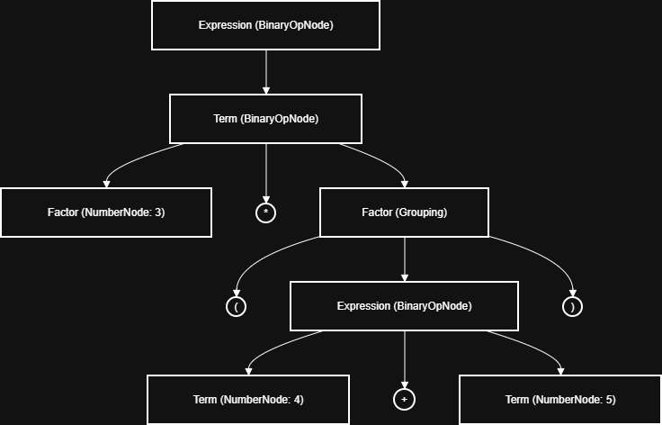

This diagram reflects a clear top-down parsing approach, which is the method implemented in the code. In this model, the parser begins with the goal of finding a complete "Expression" and works its way down to the leaves of the tree, which are the terminal integer values. This approach is highly intuitive for arithmetic because it mirrors how humans read math from the outside in, identifying the major operations before diving into nested sub-calculations. By following this visual flow, one can see exactly how the parentheses shift the addition's priority, forcing the parser to treat 4 + 5 as a single unit before multiplying by 3. This structure allows the semantics of the expression to be stored in a way that respects the mathematical order of operations.
The implementation of the parser utilizes the provided ASTNode, NumberNode, and BinaryOpNode classes to construct a valid tree from string input. Each method in the Parser class, parse_expression, parse_term, and parse_factor, directly corresponds to a specific grammar rule, ensuring that the AST structure remains faithful to the precedence hierarchy. For example, by having parse_expression call parse_term, we ensure that addition nodes stay at a higher level in the tree than multiplication nodes, which are processed deeper. To evaluate expressions, the evaluate function uses recursive semantic rules to traverse the tree in a post-order fashion. This means the interpreter solves the left and right children before applying the operator at the current node, effectively collapsing the tree into a single numerical result.
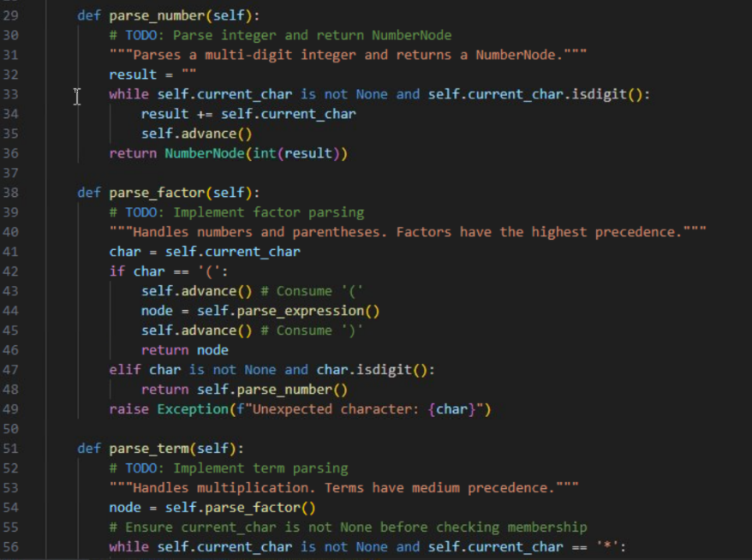
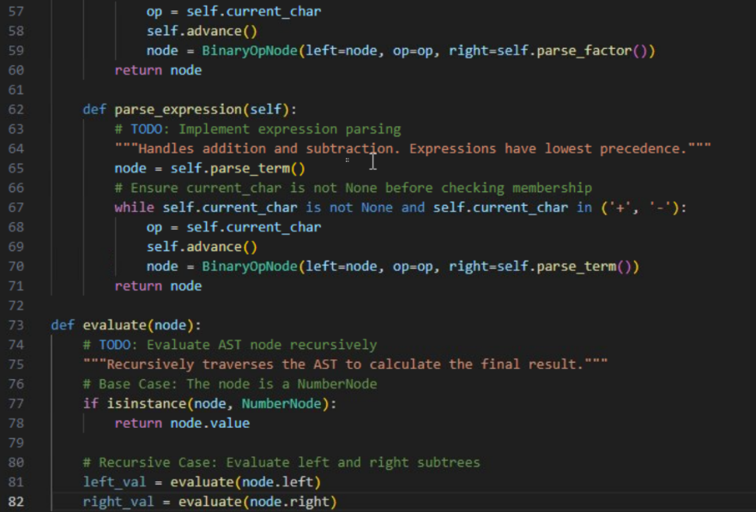
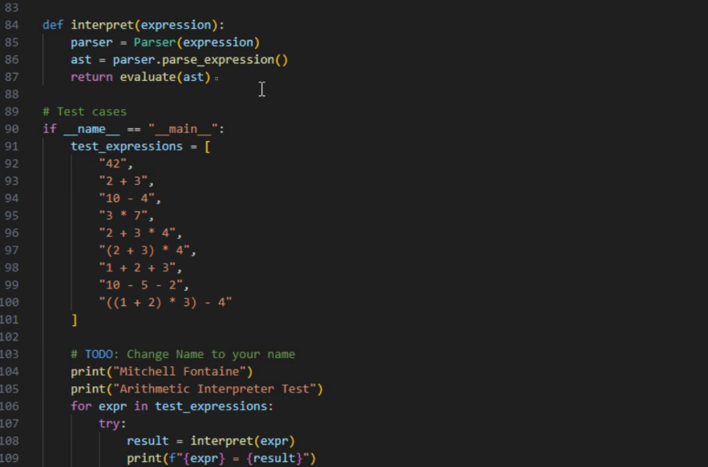
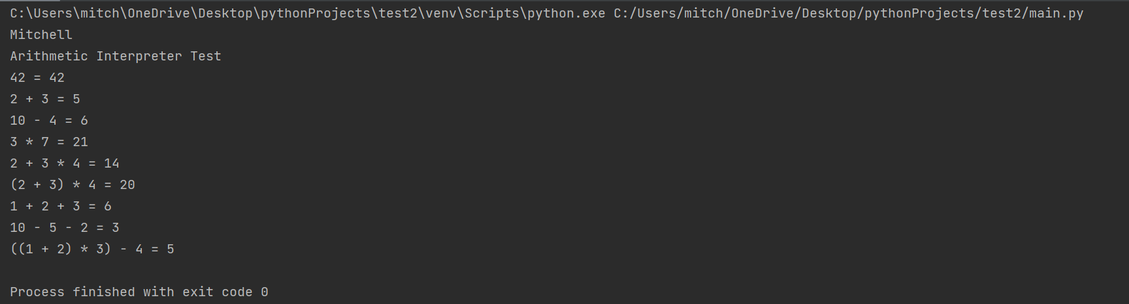
The structure of the grammar we constructed is fundamentally recursive and hierarchical, designed specifically to handle the nested nature of mathematics. By separating the rules into Expression, Term, and Factor, we create a system where the computer always knows which operation to look for next based on its precedence level. This layered design allows the grammar to be both simple and powerful, supporting an infinite variety of mathematical combinations with just a few lines of logic. It essentially acts as a set of constraints that filters raw text into a meaningful, structured format that the interpreter can actually execute. Without this structure, the computer would have no way to distinguish between 3 + 4 * 5 and (3 + 4) * 5, leading to inconsistent results.
The visual diagram represents the parsing process by acting as a snapshot of the parser's internal logic at a specific moment in time. Each line in the diagram represents a derivation step where a general rule was expanded into a specific component of the input string. This visualization is crucial for debugging, as it allows a developer to see if the parser is correctly identifying the terms and factors within a complex expression. By looking at the tree, one can immediately verify if the order of operations is being respected, as the operators that should be executed first appear lower in the diagram. It serves as a bridge between the high-level code we write and the low-level data structure the machine manipulates.
In my implementation, the parsing approach used in the grammar and diagram is strictly top-down. This means the parser starts with the most abstract concept, the expression, and attempts to prove that the input string fits that definition by breaking it down into smaller and smaller pieces. This is often called goal-oriented parsing because the program begins with a goal (finding an expression) and recursively looks for sub-goals (finding terms and factors) to satisfy it. This approach is highly efficient for LL(1) grammar like the one used here and provides a very clear mapping between the theoretical grammar rules and the final software implementation. It is the most common approach for building hand-written parsers for simple domain-specific languages.

